Steps for the motor Setup
Open the Easy Motion Studio
You have to be sure that the work offline option is not selected.
Click Communication button => Setup
Channel type: RS2332
CAN Protocol: TMLCAN (CAN 2.0B, 29 bit identifiers)
Port: COM6 (example)
Baud Rate: 115200
Axis ID of drive/motor: 1
We have to connect with the drive/motor:
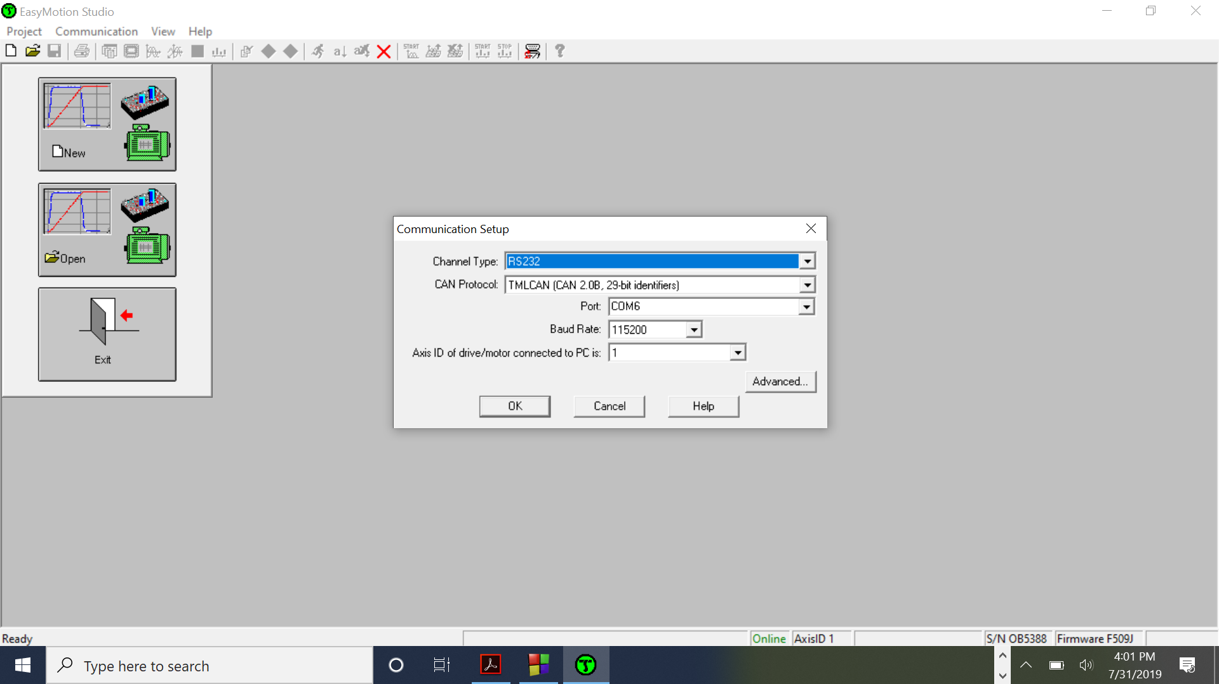
Now the indicator Has changed from Offline(Red) to Online(Green)
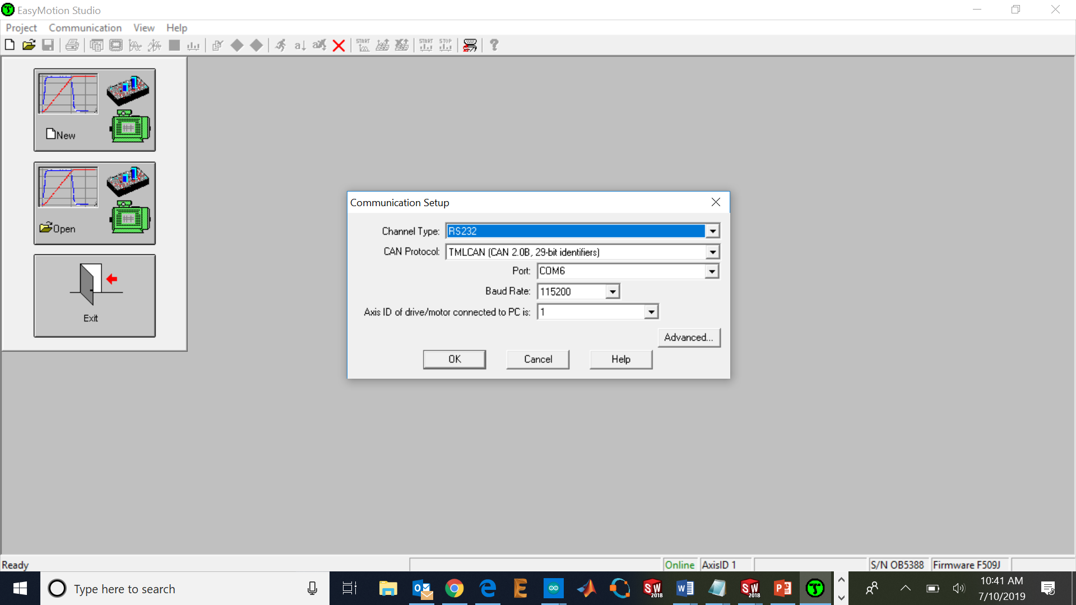
You just have to load the project in Easymotion Studio (File – Restore), download the setup to the controller and download the programs of the project to the controller (green running man - button).
All the tuning and adjustments have already been done by the company. The only thing that we must do is the adjustment of the tuning parameters of the PID position controller (kp, ki, kd) to our actual external load.

Now we select the option Project/restore: 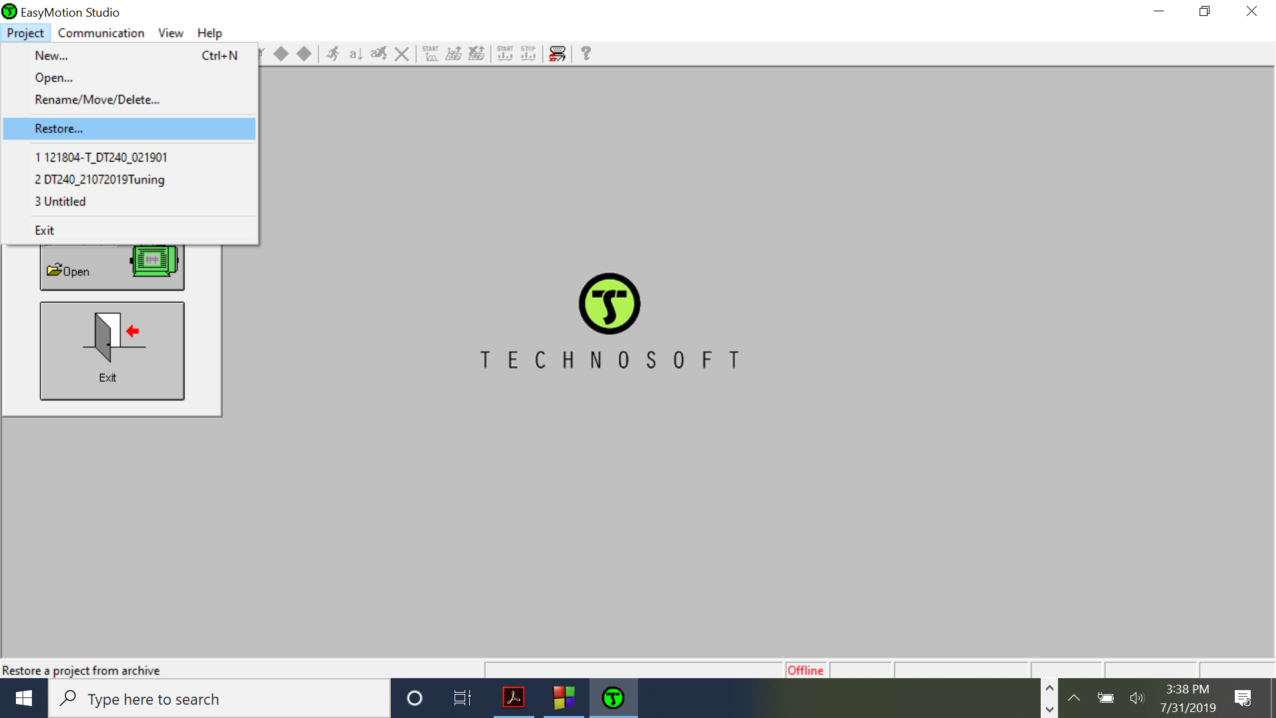
And we have to restore the m.zip setup file that comes with our software package.
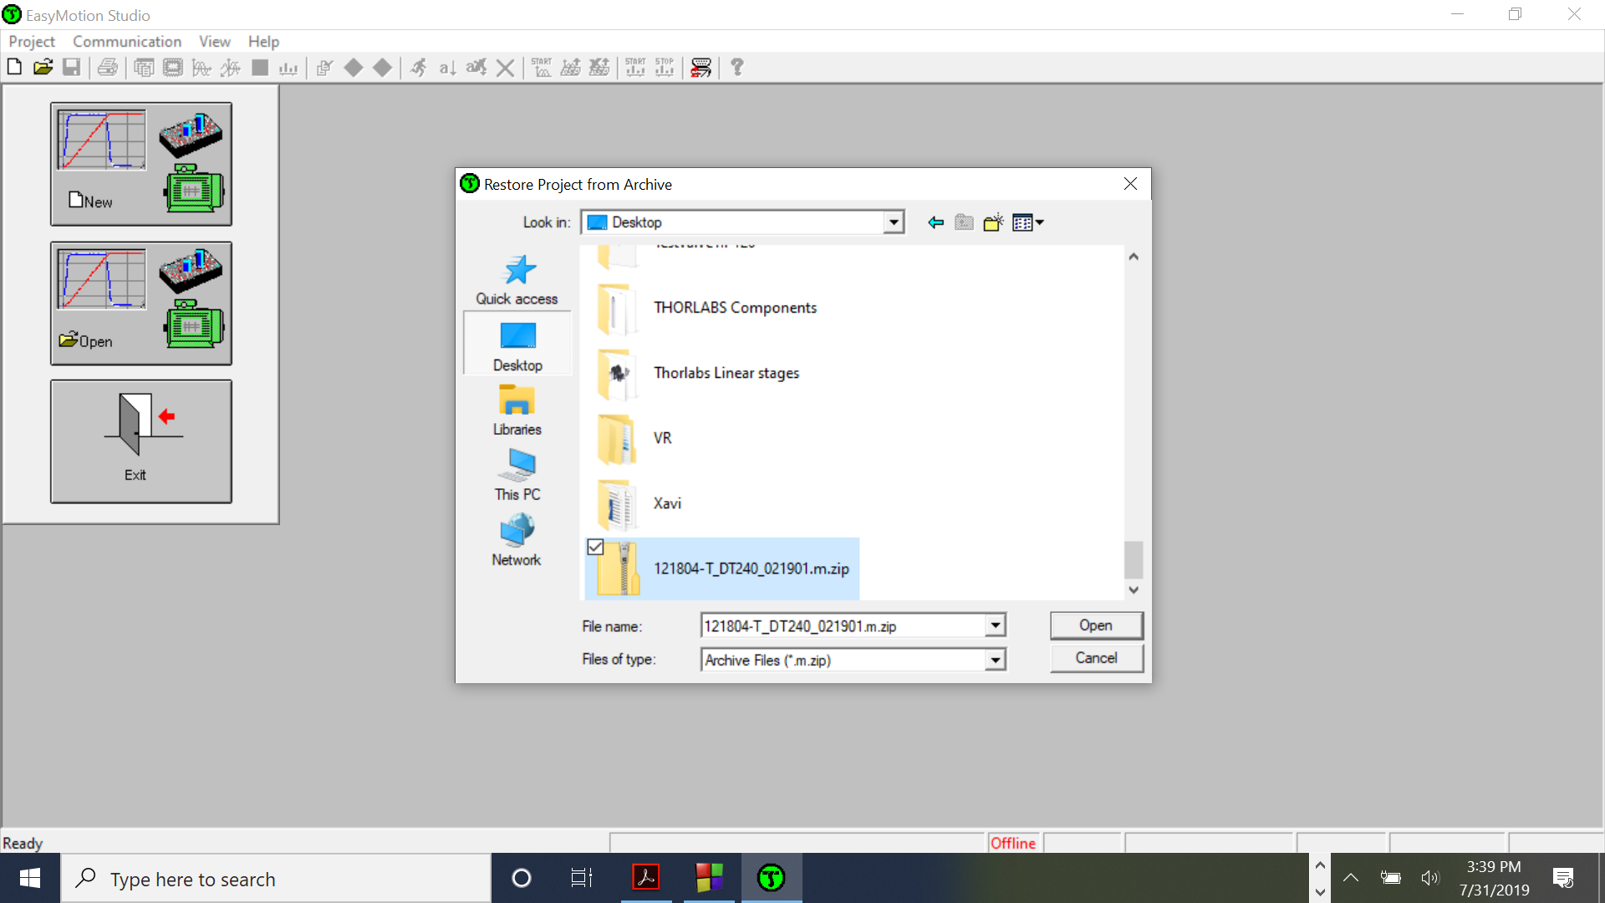
Once we click on Edit setup we can proceed adjusting the parameters to our real load.
Tuning Current controller:
The current controller has not been modified because the response did not improve changing kp and ki.
Tuning the position controller:
First of all, the value of the inertia has been updated with the actual inertia of the motor and accept the new value, in our case is one order of magnitude over the previous value (with the motor without load):
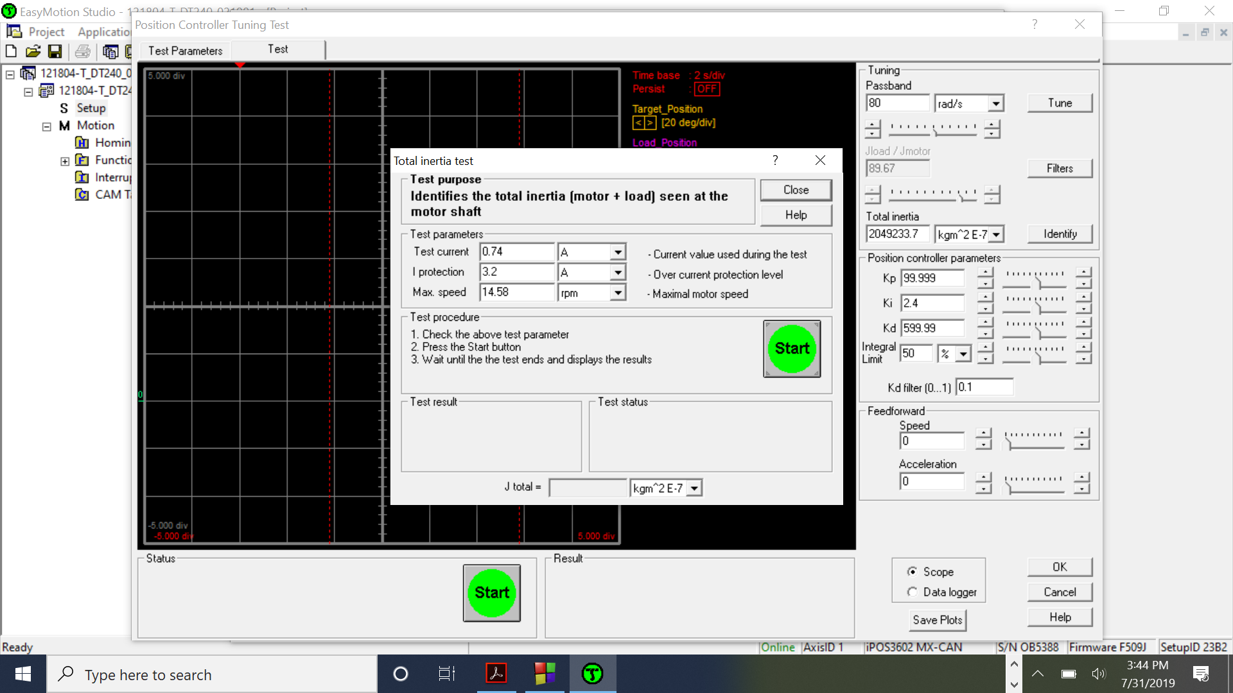
Then different configurations have been tested. Over 80 rad/s of passband, the system becomes unstable.
I get to eliminate the vibrations by applying passband of 80 rad/s: and kp= 100, ki = 2.4 and kd = 600.
With this configuration we get: not vibrations and fast acceleration to get the desired position.
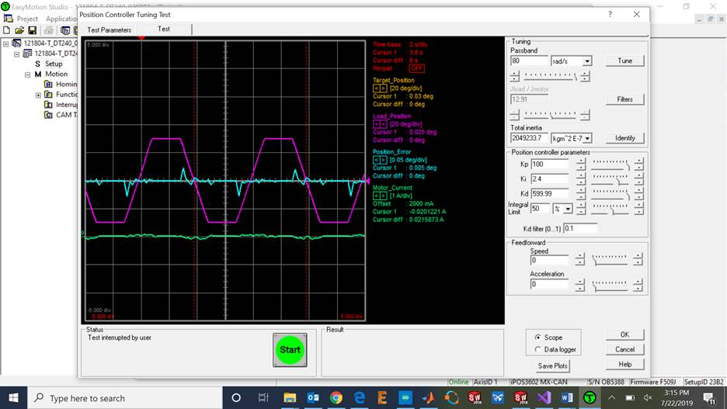
Now we have to export to TML library by clicking on Application/TML_LIB. This file will be saved on C:\Program files\Technosoft\ESM by default.
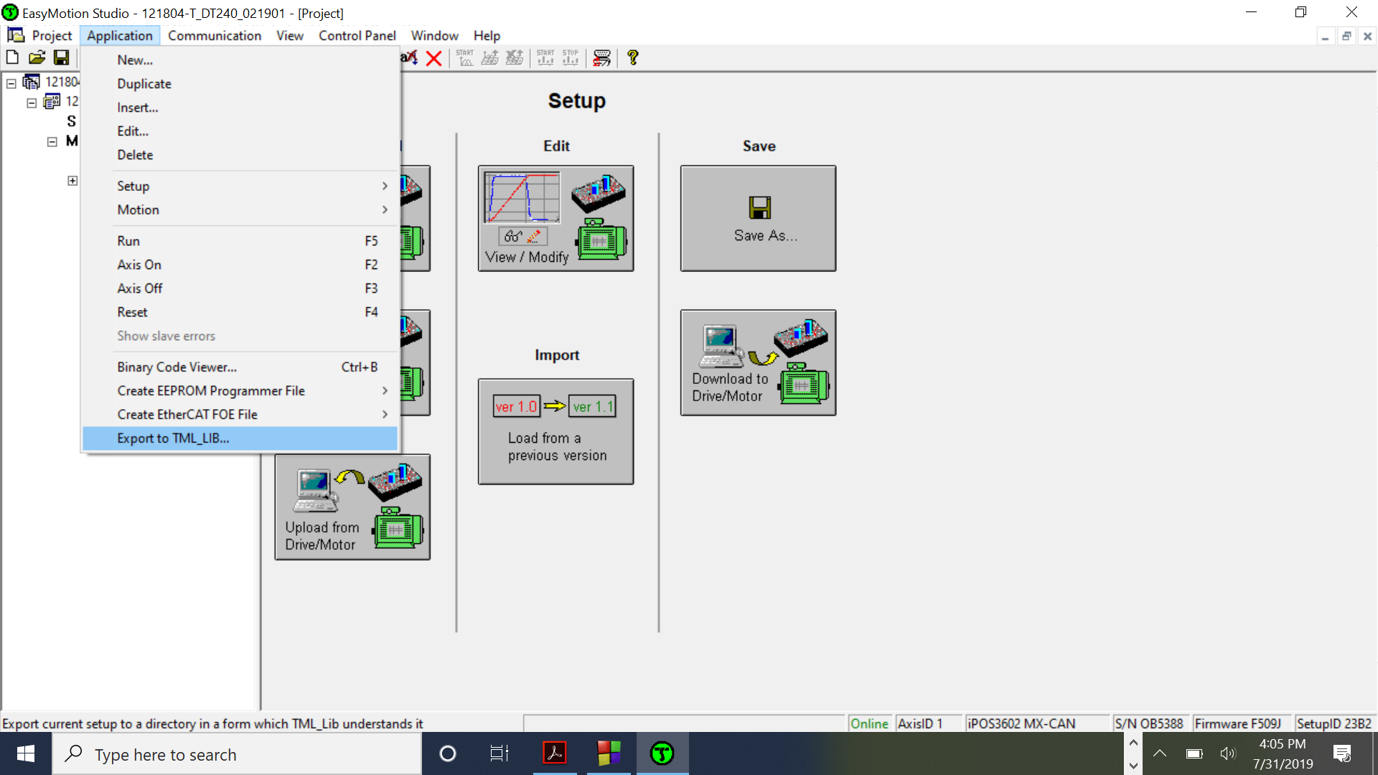
WARNING:
The Setup file .t.zip has to be copied in the Bin folder of the C# project.
Project\bin\x64\Debug
The .dll files must be copied on (TML_lib.dll and tmlcomm.dll)on the bin project file.
Project\bin\x64\Debug
And you can start programming and controlling the motor on Visual Studio (for example).
Modifications on the Definitions class:
public const int EXAMPLES_COUNT = 3;
public const String CHANNEL_NAME = "COM6";
public const byte CHANNEL_TYPE = TMLLib.CHANNEL_RS232;
public const byte HOST_ID = 1;
public const uint BAUDRATE = 115200;

public const int FALSE = 0;
public const int TRUE = 1;

public const bool NO_ADDITIVE = false;
public const bool ADDITIVE = true;
public const bool WAIT_EVENT = true;
public const bool NO_STOP = false;

public const bool OVER = true;
public const bool UNDER = false;

public const double NO_CHANGE_ACC = 0.0;
public const double NO_CHANGE_SPD = 0.0;

public const int AXIS_ID_01 = 1;
public const string SETUP_FILE_01 = "121804-T_DT240_021901_Port1.t.zip";

public const UInt16 SRL_ADDRESS = 0x090E;
public const UInt16 MER_ADDRESS = 0x08FC;

public const UInt16 DELAY = 2;

